# WEEK 3: GREEDY ALGORITHMS

**PROGRAM 1:**

**AIM:** Write a program to take value V and we want to make change for V Rs, and we have inﬁnite supply of each of the denominations in Indian currency, i.e., we have inﬁnite supply of { 1, 2, 5, 10, 20, 50, 100, 500, 1000} valued coins/notes, what is the minimum number of coins and/or notes needed to make the change.

**ALGORITHM:**

Step 1: Initialize all the variables required

Step 2: Deﬁne an array den[] and then take an input

Step 3: Iterate through the array and calculate c+=d/den[i] if den[i]<d Step 4: Display C

## PROGRAM:

#include<stdio.h>

int main()

{

int a,sum=0;

scanf("%d",&a);

if(a>=1000)

{

sum+=a/1000;

a=a%1000;

}

if(a>=500)

{

sum+=a/500;

a=a%500;

}

if(a>=100)

{

sum+=a/100;

a=a%100;

}

if(a>=50)

{

sum+=a/50;

a=a%50;

}

if(a>=20)

{

sum+=a/20;

a=a%20;

}

if(a>=10)

{

sum+=a/10;

a=a%10;

}

if(a>=5)

{

sum+=a/5;

a=a%5;

}

if(a>=2)

{

sum+=a/2;

a=a%2;

}

if(a>=1)

{

sum+=a/1;

a=a%1;

}

printf("%d",sum);

## OUTPUT:

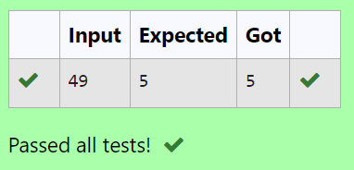

**RESULT:** Thus the program executed successfully.

## PROGRAM 2:

**AIM:** Assume you are an awesome parent and want to give your children some cookies. But, you should give each child at most one cookie.

Each child i has a greed factor g[i], which is the minimum size of a cookie that the child will be content with; and each cookie j has a size s[j]. If s[j] >= g[i], we can assign the cookie j to the child i, and the child i will be content. Your goal is to maximize the number of your content children and output the maximum number.

### ALGORITHM:

Step 1: Input the size of the first array g[] and its elements. Step 2: Input the size of the second array s[] and its elements. Step 3: Compare each element of g[] with the elements of s[]. Step 4: Output the result.

### PROGRAM:

#include<stdio.h>

int main()

{

int n,c,k;

scanf("%d",&n);

int s[n];

for(int i=0;i<n;i++)

{

scanf("%d",&s[i]);

}

scanf("%d",&c);

int h[c];

for(int i=0;i<c;i++)

{

scanf("%d",&h[i]);

}

for(int i=0;i<n;i++)

{

for(int j=0;j<c;j++)

{

if(s[i]>=h[j])

k=h[j];

}

}

printf("%d",k);

}

### OUTPUT:

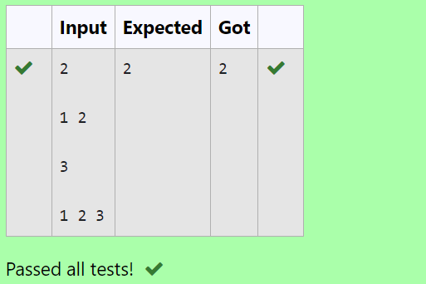

**RESULT:** Thus the program was executed successfully.

### PROGRAM 3:

**AIM:** A person needs to eat burgers. Each burger contains a count of calories. After eating the burger, the person needs to run a distance to burn out his calories.

If he has eaten *i* burgers with c calories each, then he has to run at least *3i * c* kilometers to burn out the calories. For example, if he ate 3

burgers with the count of calorie in the order: [1, 3, 2], the kilometers he needs to run are (30 * 1) + (31 * 3) + (32 * 2) = 1 + 9 + 18 = 28.

But this is not the minimum, so I need to try out other orders of consumption and choose the minimum value. Determine the minimum distance He needs to run.

### ALGORITHM:

Step 1: Input the size of the array a[] and its elements. Step 2: Sort the array in descending order.

Step 3: Calculate the sum with weighted powers. Step 4: Output the result.

### PROGRAM:

#include<stdio.h>

#include<math.h>

int main()

{

int n,temp;

scanf("%d",&n);

int a[n];

for(int i=0;i<n;i++)

{

scanf("%d",&a[i]);

}

for(int i=0;i<n;i++)

{

for(int j=i+1;j<n;j++)

{

if(a[i]<a[j])

{

temp=a[i];

a[i]=a[j];

a[j]=temp;

}

}

}

int sum=0;

for(int i=0;i<n;i++)

{

sum+=((pow(n,i))*a[i]);

}

printf("%d",sum);

}

### OUTPUT:

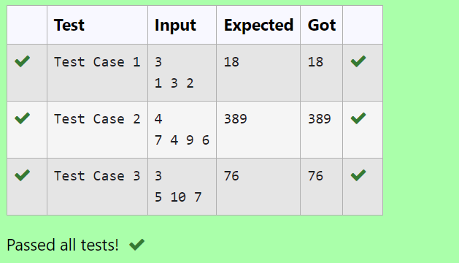

**RESULT:** Thus the program was executed successfully.

### PROGRAM 4:

**AIM:** Given an array of N integer, we have to maximize the sum of arr[i] * i, where i is the index of the element (i = 0, 1, 2, ..., N).Write an algorithm based on Greedy technique with a Complexity O(nlogn).

## ALGORITHM:

Step 1: Input the size of the array a[] and its elements. Step 2: Sort the array a[] in ascending order.

Step 3: Calculate the weighted sum.

Step 4: Output the result.

## PROGRAM:

#include<stdio.h>

int main()

{

int n,temp;

scanf("%d",&n);

int a[n];

for(int i=0;i<n;i++)

{

scanf("%d",&a[i]);

}

for(int i=0;i<n;i++)

{

for(int j=i+1;j<n;j++)

{

if(a[i]>a[j])

{

temp=a[i];

a[i]=a[j];

a[j]=temp;

}

}

}

int sum=0;

for(int i=0;i<n;i++)

{

sum+=(a[i])*i;

}

printf("%d",sum);

}

## OUTPUT:

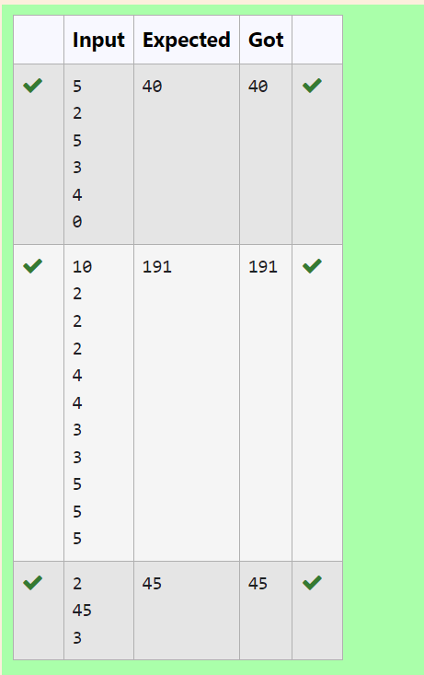

**RESULT:** Thus the program executed successfully.

## PROGRAM 5:

**AIM:** Given two arrays array_One[] and array_Two[] of same size N. We need to first rearrange the arrays such that the sum of the product of pairs( 1 element from each) is minimum. That is SUM (A[i] * B[i]) for all i is minimum.

### ALGORITHM:

Step 1: Input the size of the arrays and the elements of both arrays a[] and b[]. Step 2: Sort array a[] in descending order and array b[] in ascending order.

Step 3: Calculate the sum of products. Step 4: Output the result.

### PROGRAM:

#include<stdio.h>

int main()

{

int n,sum=0,temp=0;

scanf("%d",&n);

int a[n];

for(int i=0;i<n;i++)

{

scanf("%d",&a[i]);

}

int b[n];

for(int i=0;i<n;i++)

{

scanf("%d",&b[i]);

}

for(int i=0;i<n;i++)

{

for(int j=i+1;j<n;j++)

{

if(a[i]<a[j])

{

temp=a[i];

a[i]=a[j];

a[j]=temp;

}

}

}

for(int i=0;i<n;i++)

{

for(int j=i+1;j<n;j++)

{

if(b[i]>b[j])

{

temp=b[i];

b[i]=b[j];

b[j]=temp;

}

}

}

for(int i=0;i<n;i++)

{

sum+=a[i]*b[i];

}

printf("%d",sum);

}

### OUTPUT:

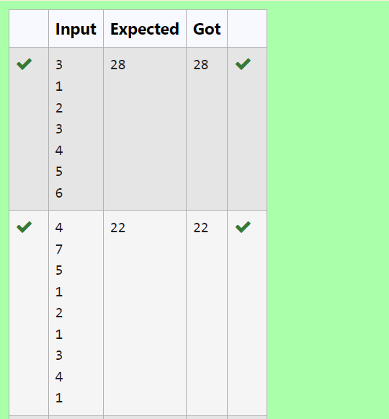

**RESULT:** Thus the program was executed successfully.